Robert Skelton

9.7.2012

Signals and Systems

MATLAB Project 1

1. X(t) = cos(2t)

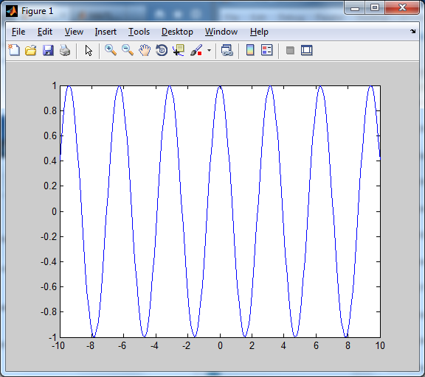

1. V(t) = cos(3)

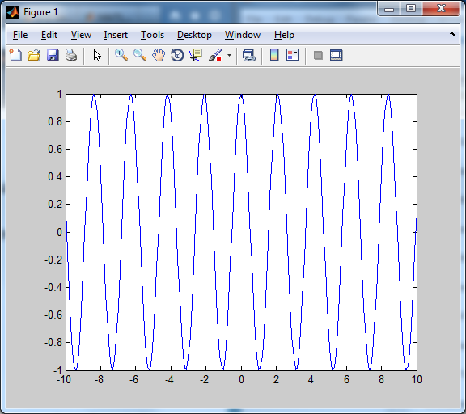

(3) y(t)=acos(2t)+bcos(3t) for   
(i) a=3, b=1

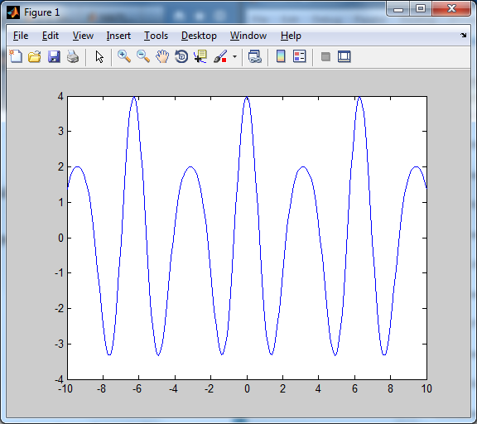

(ii) a=1, b=3

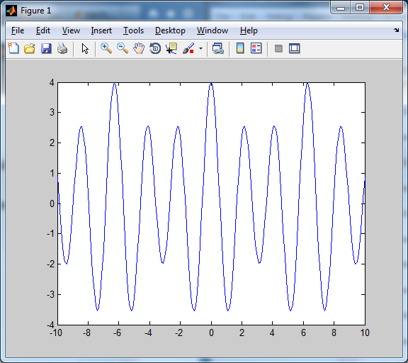

(iii) a=1, b=1  
